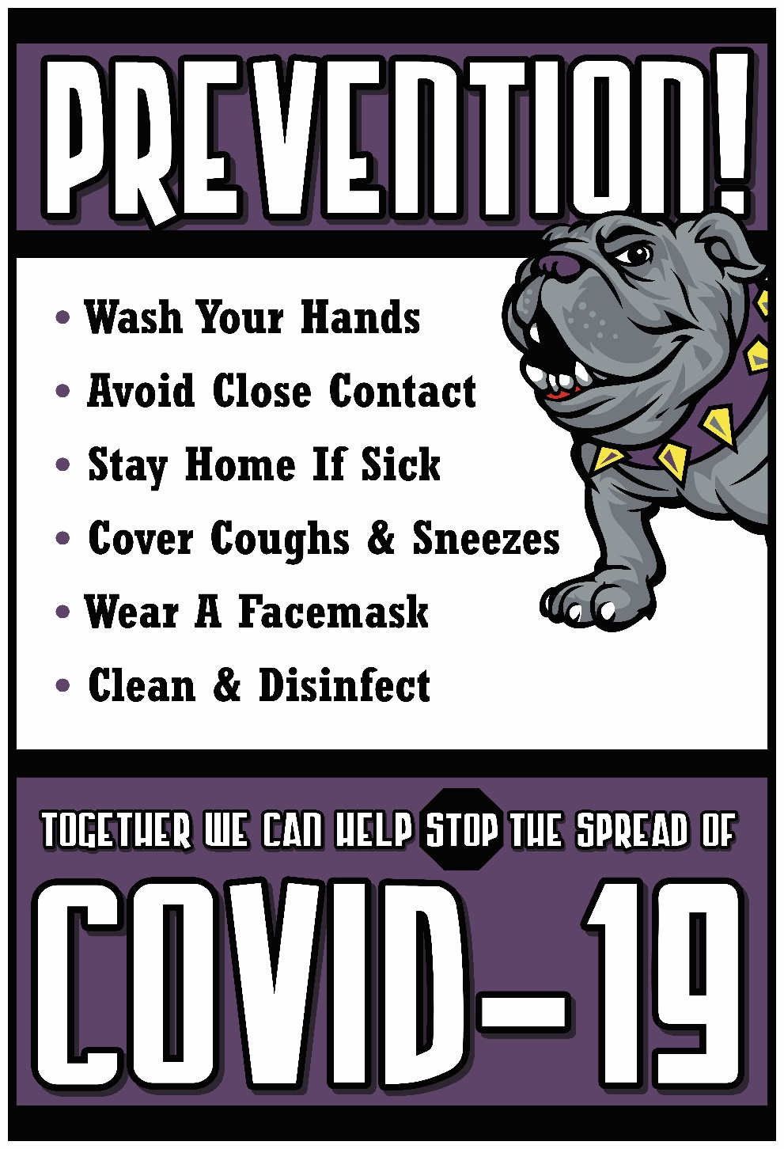

|  |
| --- |
| Butte School District  Three-Phased  Reopening Plan |
|  |
| 2020-2021 |

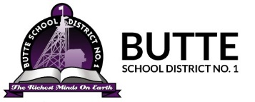

**Dear Families,**

Once again it is my privilege to welcome you to another school year that holds the promise of yet another “Butte Can Do” challenge. This year, perhaps more than any other year, holds the promise of reflection, a reflection on challenges faced and challenges met. The 2020-2021 school year will see an opening unlike anything in previous years as the corona virus necessitates major changes in regards to student health and safety.

With student safety of paramount importance, our goal this year is to open our school doors and remain open emphasizing the same quality, student centered, progressive education that has always been the mission of the Butte School District. In order to ensure the health and safety of your child and our staff, we have instituted health related guidelines in collaboration with Governor Bullock’s office and the Butte Silver Bow Health Department.

These guidelines include limiting student contacts through the use of cohorts that reduce contact numbers to 50 or less, by eliminating hallway congestion through staggered dismissals, and serving breakfast and lunch in the classroom. Also, in addition to social distancing, the district is committed to an emphasis on personal hygiene, the use of masks, and building sanitation.

In closing, I cannot adequately express my gratitude to all our parents, staff and the entire Butte community for their overwhelming support of our school district and our students. How very fortunate I feel to be part of such a wonderful school district and community. Rest assured that we will use all the resources at our disposal to ensure that our students and staff have a safe and productive school year.

**THANK YOU FOR WEARING YOUR MASK!!**

Sincerely,

Judy Jonart 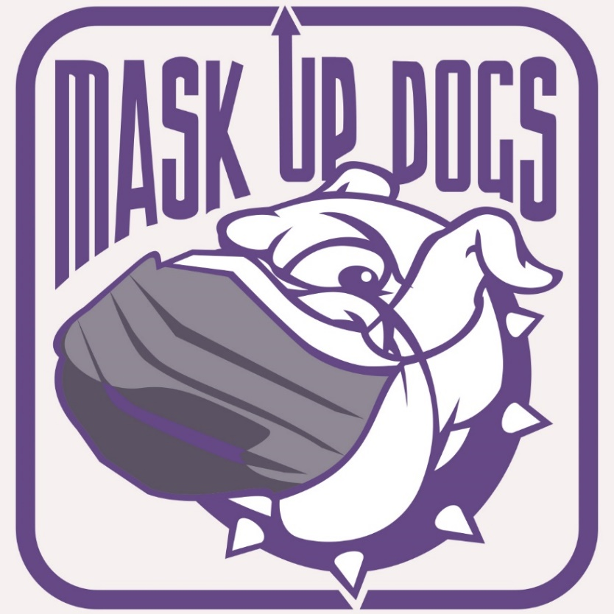

Superintendent

Butte School District

Butte, MT 59701

A special thank you to the following individuals and for their generous contribution, support and work in developing and implementing the reopening plan. They deserve our full recognition and appreciation as a school district and community.

Ms. Mary Kaye Ericson, Assistant to Superintendent

Mr. Kevin Patrick, Business Director

Ms. Therese McClafferty, Human Resource Director

Ms. Marci Sheehan, Administrative Assistant, Business Department

Ms. Aaryn Hayden, Administrative Assistant, Human Resource Department

Mr. Jim O’Neill, Curriculum Director

Ms. Tawni Emett, Curriculum Secretary

Mr. Chuck Merrifield, BHS Assistant Principal

Butte High School Coaching Staff

Mr. John Metz, Butte High Principal

Ms. Brenda Floreen, BHS Assistant Principal

Ms. Jen Gilliard, Hillcrest Task Force

Ms. Chris Renz, Special Ed Secretary

Ms. Lorrie Roberts, BHS Principal Secretary

Mr. Cory Woolverton, BSD IT Department

Mr. Nick Barney, IT Department

Ms. Cathy Cashell, IT Department

Ms. Maureen Bowman, IT Department

Ms. Dot Warner, Butte High School Nurse

Ms. Katie Yates, Butte Elementary Nurse

Ms. Jenni McEwen, Butte Elementary Nurse

Ms. Barb Brown, Butte Elementary Nurse

Mr. Jeremey Whitlock, Butte School District Transportation/Facilities Director

Ms. Kelsey Chase, Transportation Secretary

Ms. Kelsey Williams, Transportation Secretary

Mr. Kurt Marthaller, Central Service Director

Ms. Cathy Corak, Central Services Secretary

Mr. Keith Miller, EMS Principal

Mr. Ron Ricketts, EMS Asst. Principal

Ms, Shani Bailey, EMS Dean

Ms. Cindy Ammondson, EMS Counselor

Ms. Karen Alley, EMS Task Force

Ms. Laurie Rossberg, EMS Task Force

Ms. Rochelle Ryan, EMS Task Force

Ms. Kathy Foley, EMS Task Force

Ms. Kacie Queer, EMS Task Force

Mr. Mike Kennsion, EMS Task Force

Ms. Kathy Cannon, Special Education Director

Ms. Melissa Johnson, Asst. Special Ed Director

Ms. Deanna Queer, BHCC Task Force

Ms, Kristen Lee, BHCC Task Force

Ms. Megan Paul, BHCC Task Force

Mr. Travis Johnson, Principal Kennedy

Ms. Tina Powers, Kennedy Task Force

Ms. Jenni Reilly, Kennedy Task Force

Ms. Michelle St. Pierre, Kennedy Task Force

Ms., Jennifer Luoma, Principal, M Leary

Ms. Patty O’Neill, West Elementary Task Force

Ms. Amie Quist, West Elementary Task Force

Ms. Jennifer Liva, West Elementary Task Force

Mr. Josh Schad, Principal Whittier Elementary

Ms. KD Kennis, Whittier Task Force

Ms. Micheala Tomsheck, Whittier Task Force

Ms. Kristine Anderson, M Leary Task Force

Ms. Becky Salvagni, M Leary Task Force

Mr. John Rolich, BSB Health Department

Ms. Karen Sullivan, BSB Health Department

Ms. Stephanie Moodry, BSB Health Department

Ms. Michelle Kelly, West Task Force

Ms. Karen Maloughney, BSB Health Dept.

Mr. Chad Jonart, BHCC Task Force

Ms. Amy Guldseth, M Leary Task Force

Mr. Pat Kissell, Principal West Elementary

Ms. Susan Johnson, Principal Hillcrest

Ms. Brenda Miner, Principal Emerson

Ms. Amie Trudinowski, Emerson Task Force

Ms. Judy Vinecke, Emerson Task Force

Ms. Paulette Stanich, Hillcrest Task Force

Ms. Cindy Merrick, Hillcrest Task Force

Ms. Pat Powers, BHS Athletics

**Table of Contents**

Framework of Three Phased Reopening Plan1

School Schedules for Phases10

Overview Remote Learning…………………………………………………………………………………….................19

Butte School District Support Services……………………………………………………………………………….….17

Determining Operational Phases within the BSD Reopening Plan………………………………………………..…...19

Health/Safety Protocols………………………………………………………………………………………………...…24

Cleaning/Disinfecting Protocols……………………………………………………………………………….................29

Transportation………………………………………………………………………………………………………….....34

School Nutrition Services………………………………………………………………………………………..……….35

References……………………………………………………………………………………………………………..…..36

Appendix A: Butte Silver Bow Health Department Data…………………………………………………………..….37

Appendix B: Frequently Asked Questions for Butte School District Staff……………………………………….......39

Appendix C: Frequently Asked Questions for Butte School District Students………………………………………44

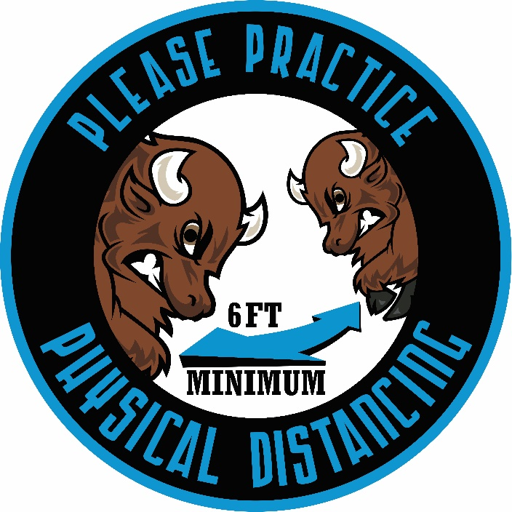

Framework of Three -Phased Reopening Plan

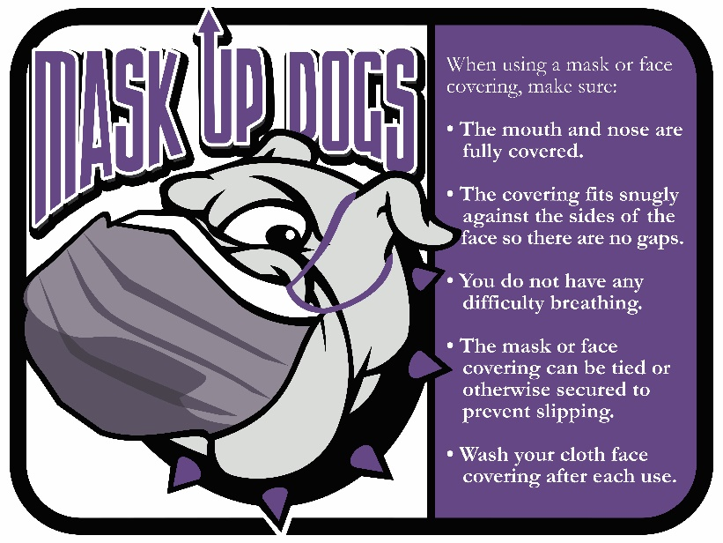

The following is the framework of the Butte School District Three-Phased Reopening Plan that outlines the instructional programs that will be offered to all Butte School District students within the three phases contained in the Governor’s Reopening Montana Plan. The plan offers three different instructional models that are unique to each of the phases. Additionally, the plan does acknowledge that in the event of a state/local directive to close schools the entire district would go to remote learning. It is also important to note that the remote learning option will be available to students throughout the duration of the COVID -19 crisis.

Each of the three phases were designed with the following focus:

Focus on Safety and Health

Focus on Students

Focus on Families

Focus on Consistency

Focus on Quality Instruction

Focus on Emotional/Social Support

Focus on Flexibility

Focus on Technology

Focus on Training

The plan was designed with the health and welfare of all our students and staff as our priority. Successful implementation of the plan will require a level of collaboration and cooperation unlike any other year. It is only by working together that we will be able to provide the necessary supports to our students, families, and educators. We must all dedicate ourselves to working together to create a positive responsive learning environment that will help reduce the stress and apprehension that will undoubtedly be felt by many as we begin the 2020-2021 school year.

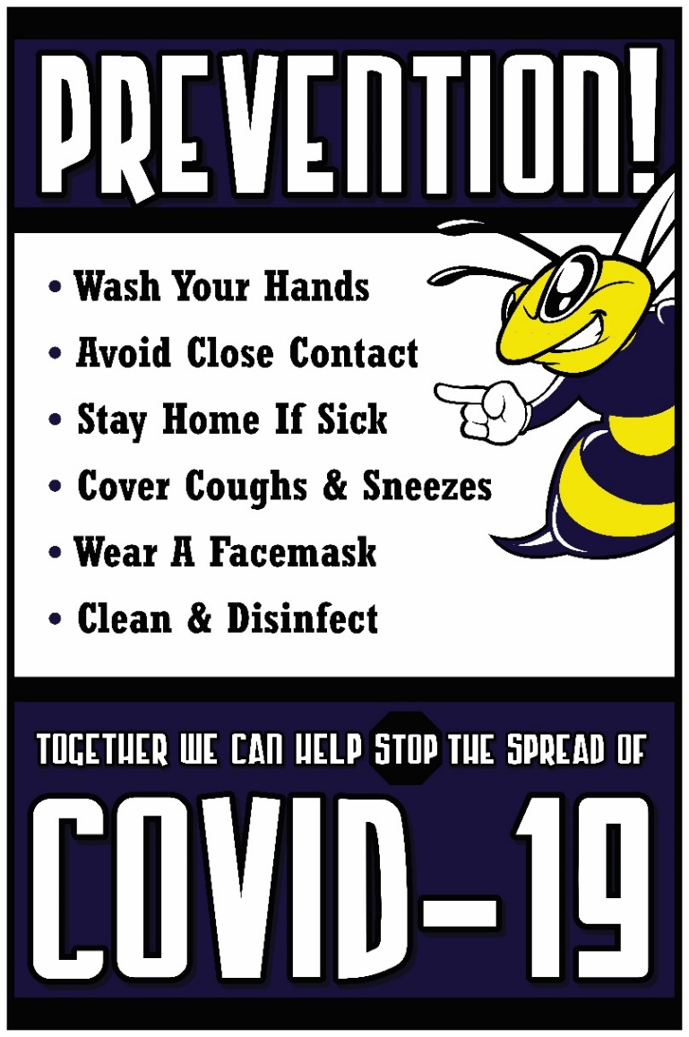Butte School District Reopening Plan

Focus on Health and Safety:

BSD Reopening Plan offers three different instructional models that are unique to each of the phases. The plan was designed taking into consideration the unique needs of each grade level and include safety measures that will help keep our students, staff and our entire community safe. The plan was developed in collaboration with the Butte Silver Bow Health Department, Governor’s Office, state educational organizations, CDC, and the Montana Office of Public Instruction.

Focus on the Individual Student:

BSD Reopening Plan provides remote learning option throughout all phases of the plan. Families have the opportunity to request remote learning throughout the duration of the COVID-19 crisis. All support services will be in place for all students in grades K-12 including academic and emotional/social supports.

Focus on Building Strong Family and Student Relationships:

BSD will utilize a variety of technology tools in order to work with parents on a consistent and ongoing basis to ensure that the district is providing the necessary support needed for students to succeed. Social emotional support will be available to all our students including those students enrolled in remote learning.

Focus on Nutrition:

Montana Governor Recognition for the successful

implementation of the “Breakfast After the Bell Program in all schools. Grab-n-Go Breakfast and lunches will also continue to be available to students enrolled in our remote learning option.

Focus on Technology:

BSD will begin to implement its student laptop program during the 2020-2021 school year providing 1:1 ratio for all students in grades 3-12. Students in grades K-2 will have access to classroom mobile labs. Additionally, BSD will also have “hotspots” available to students needing access to the internet at home. Remote learners will be able to check out equipment in order to access all online resources. All students and staff will have on-going training using the various technology tools and applications throughout the school year.

Focus on Training:

BSD has designed a comprehensive training schedule for all student, staff, and parents regarding COVID-19. The training was developed by the Butte School District Nursing Staff, Mr. John Rolich, BSB Health Department, and Mr. Brodie Loushin, PayneWest Risk Control Specialist, who along with manufacture representatives/dealer provided training on proper use of disinfectant, sanitizing and cleaning products and equipment.

Focus on Flexibility and Consistency:

BSD developed the reopening plan in such a way that would allow for a smooth transition between phases with little or no disruption to instruction. The plan was also designed to allow for students to have a consistent schedule regardless if they were attending school in-person or enrolled in remote learning.

Butte School District Framework of Three Phased Reopening Plan

|  |  |  |  |
| --- | --- | --- | --- |
| ***Phases*** | ***State/Local Mandates*** | ***Butte School District***  ***Health Safety Procedures*** | ***Butte School District Instructional Plan*** |
| **Phase 0**  **Stay at-home Order** | State/ local mandated school closure | All schools closed | All remote learning for all students K-12 |
| **Phase 1**  **Blended Learning Model** | Schools open for in person instruction limiting building capacity and group size. | This plan would be implemented if allowable group size went below 50 and building capacity was limited.  Health screening for students done at home.  Handwashing taught using a dedicated time throughout the day  Outside venues will be encouraged whenever possible especially when developing traffic routes at individual buildings.  Frequent sanitizing of surfaces and bathrooms.  Social Distancing maintained.  Face coverings required for all grades K-12  No visitors will be allowed in the school. Parents will need to schedule a meeting with school staff and it is highly recommended that parent meetings be held virtually.  Extensive training on proper procedures and protocols for disinfecting, reporting symptoms, proper techniques for wearing PPE, social distancing, provided to all staff and students.  Parent training on home health screenings, wearing masks, social distancing, and hand sanitizing will be available online.  All classrooms will be equipped with proper PPE and supplies.  Board meetings will be conducted using a blended model including remote and/or in person meeting  School operates under Board declared emergency resolution. | Students attend school in- person (2-3 days a week using an A/B schedule and remote learning the rest of the week. Buildings would be reduced to half capacity.  Instruction would include both in -person and synchronous/ asynchronous remote learning  Schedules would be developed to keep family members attending school on the same days.  Modified daily schedule. This modified schedule allows for lunch in the classroom and proper daily sanitization.  Students will be assigned to cohorts in order to limit large group gatherings.  Lunch in the classroom  No large gatherings or assemblies  Extra -curricular activities will be scheduled in collaboration with the Butte Silver Bow Health Department.  All school facilities will be closed to public rental.  Community Education Program canceled to in person instruction  Administrative/Staff meetings should be conducted if at all possible via TEAMS Meeting platform.  Remote Learning available to all K-12 students.  Reduced rider capacity on buses |
| **Phase II**  **Cohort Learning Plan** | Schools open for in person instruction. Limits group size to 50 | Health screening for students done at home  Student training on handwashing, social distancing, and wearing masks will be taught to students on a regular basis.  Dedicated hand washing will be scheduled throughout the day  Masks/face coverings will be mandated for all grades K-12.  Outside venues will be encouraged whenever possible especially when developing traffic routes at individual buildings  No large gatherings or assemblies  Lunch in the classroom  No visitors will be allowed in the buildings. Parents will need to schedule a meeting with school staff and it is highly recommended that parent meetings be held virtually.  Frequent sanitizing of surfaces and bathrooms  Reduced rider capacity on buses  Parent training on home health screenings, wearing masks, social distancing, and hand sanitizing will be available online.  Extensive training on proper procedures and protocols for disinfecting, reporting symptoms, proper techniques for wearing PPE, social distancing, provided to all staff and students.  All classrooms will be equipped with proper PPE and supplies.  Board meetings will be conducted using a blended model including remote and/or in person meetings.  School operates under a Board declared emergency resolution. | In person instruction for all students 5 days a week, limits group size to 50 persons or less includes some remote learning activities.  Instruction would include both in -person and synchronous/ asynchronous remote learning  Modified School Day Schedule. This modified schedule allows for lunch in the Classroom, proper daily sanitization, and retains the cohort  Students will be assigned to cohorts in order to limit large group gatherings.  Lunch will be in the classroom, and recess will be scheduled with cohort group.  Remote Learning available to all K-12 students.  Extra-curricular activities will be scheduled to reduce exposure and to keep students in the same cohorts. These schedules will be developed based on the guidelines from MHSA, the governor’s reopening plan, CDC recommendations, and Butte Silver Bow Health Department  Bell schedules will be modified and staggered to reduce traffic in hallways, entrances/exits, gym areas.  Administrative/Staff meetings should be conducted if at all possible via TEAMS Meeting platform.  Parents have an option to continue with remote learning. Community Education Program canceled for in person instruction  All school facilities will be closed to public rental. |
| **Phase III** | All state and local restrictions lifted | Health screenings for students done at home.  Student training on hand washing and healthy hygiene practices will continue to be taught on a regular and consistent manner  Continue to follow all disinfecting and cleaning protocols  Visitors may be allowed in the buildings. Continue to encourage parents to schedule meetings with school staff prior to coming to school.  Extensive training on proper procedures and protocols for normal sanitization and disinfecting and healthy hygiene will continue to be provided to all staff.  All classrooms will be equipped with proper sanitizing and disinfectant supplies.  Board meetings will continue to be conducted using a blended model of in -person and remote meetings.  Board lifts emergency resolution. | In person instruction all students 5 days a week.  Return to regular school daily schedule. (See 2020-21 School Calendar)  Lunch room schedules resume.  Recess schedules resume.  Transportation schedules resume to full capacity.  Extra-curricular activities operate at full capacity.  Rental agreements restored to normal practices.  Community Education Program return to in person instruction.  Administrative/Staff meetings will continue to utilize a blended model to conduct meetings including in-person and remote meetings. |

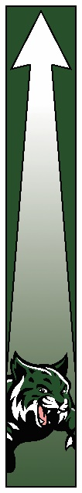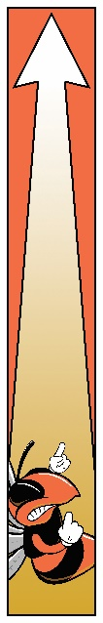

Phase I Schedules:

AA/BB Schedule

|  |  |  |  |  |  |
| --- | --- | --- | --- | --- | --- |
| **Cohort** | **Monday** | **Tuesday** | **Wednesday** | **Thursday** | **Friday** |
| **A** | In- Person | In-Person | Remote | Remote | Remote |
| **B** | Remote | Remote | In-Person | In-Person | Remote |

Daily Schedule:

|  |  |  |
| --- | --- | --- |
| **Grades** | **Start Time** | **Dismissal** |
| **K-3** | 8:20 AM | 1:00 AM |
| **4-12** | 8:20 AM | 2:00 AM |

Please Note: These schedules are only used within Phase 1 of the District’s Reopening Plan

Example of Block Schedule:

|  |  |  |  |
| --- | --- | --- | --- |
|  | **1st Grading Period** | **2nd Grading Period** | **3rd Grading Period** |
| **Block 1:**  **8:20-11:00 AM**  **Instruction** | 1st Period | 2nd Period | 3rd Period |
|  |  |  |  |
| **Block 2:**  **11:05-2:00**  **Instruction/Lunch** | 6th Period | 5th Period | 4th Period |
| **2:00 PM** | Dismissal | Dismissal | Dismissal |

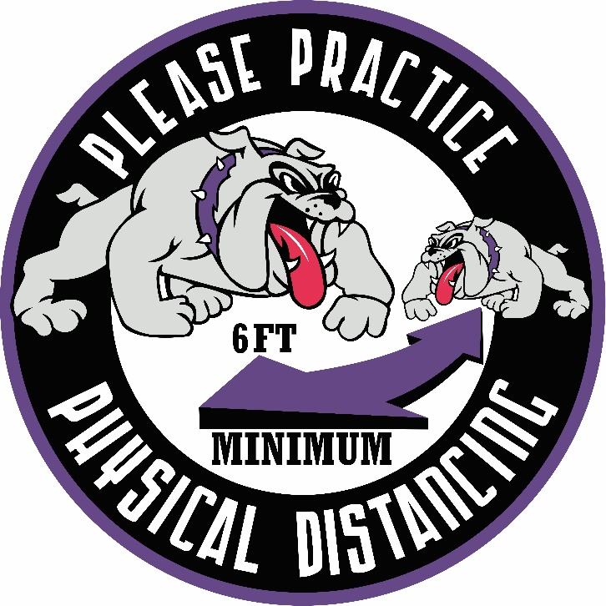

Phase II Schedules:

Example of Schedule for Phase II of Butte School District Reopening Plan

(*Please note this is just an example of a schedule. Individual student schedules will be available prior to school* starting).

Butte High School 2- Block Per Day Schedule Considerations

Grading Period Schedule

Semester Schedule

|  |  |  |  |
| --- | --- | --- | --- |
|  | **1st Grading Period** | **2nd Grading Period** | **3rd Grading Period** |
| **Block 1:**  **8:20-11:00 AM**  **Instruction** | 1st Period | 2nd Period | 3rd Period |
|  |  |  |  |
| **Block 2:**  **11:05-2:00**  **Instruction/Lunch** | 6th Period | 5th Period | 4th Period  *(Note Friday Dismissal is at 11:30 see weekly schedule)* |
| **2:00 PM** | Dismissal | Dismissal | Dismissal |

Example of Student Weekly Schedule

1st Grading Period

|  |  |  |  |  |  |
| --- | --- | --- | --- | --- | --- |
| **Block** | **Monday** | **Tuesday** | **Wednesday** | **Thursday** | **Friday** |
| 8:20-11:00 | Block 1  1st Period | Block 1  1st Period | Block 1  1st Period | Block 1  1st Period | |  |  | | --- | --- | | Weeks 1-3  1st Period | Weeks 4-6  6th Period | |
| 11:05-2:00  Lunch in Classroom | Block 2  6th Period | Block 2  6th Period | Block 2  6th Period | Block 2  6th Period | 11:05Dismissal  Remote Learning |
| 2:00 | Dismissal | Dismissal | Dismissal | Dismissal |  |

East Middle School Block Schedule: Example of one 7th Grade Team

|  |  |  |  |  |
| --- | --- | --- | --- | --- |
| **TEAM D** | **Cohort**  **40 (Students)** | **1st Grading Period (6 Weeks)** | **2nd Grading Period (6 Weeks)** | **3rd Grade Period**  **(6 Weeks)** |
| Block 1  8:20-10:55 | 7 D Cohort 1 | Reading /English | Math/Science | Social Studies  PE/Elective |
| 10:55-11:20 |  | Lunch | Lunch | Lunch |
| Block 2  11:20-2:00 | 7 D Cohort 2 | English/Reading | Science/Math | |  | | --- | | PE (11:20-12:40) | | Elective (12:45-2:00) | |
| 2:00-3:00 | Dismissal | Dismissal | Dismissal | Dismissal |

|  |  |  |  |  |
| --- | --- | --- | --- | --- |
| **Team D** | **Cohort**  **(40 Students)** | **1st Grading Period (6 Weeks)** | **2nd Grading Period (6 Weeks)** | **3rd Grade Period**  **(6 Weeks)** |
| Block 1  8:20-10:55 | 7 D Cohort 3 | Social Studies  PE/Elective | Reading/English | Math/Science |
| 10:55-11:20 |  | Lunch | Lunch | Lunch |
| Block 2  11:20-2:00 | 7 D Cohort 4 | |  | | --- | | PE (11:20-12:40) | | Elective (12:45-2:00) | | Reading/English | Math/Science |
| 2:00 | Dismissal | Dismissal | Dismissal | Dismissal |

|  |  |  |  |  |
| --- | --- | --- | --- | --- |
| **Team D** | **Cohort**  **(40 Students)** | **1st Grading Period (6 Weeks)** | **2nd Grading Period (6 Weeks)** | **3rd Grade Period**  **(6 Weeks)** |
| Block 1  8:20-10:55 | 7 D Cohort 5 | Math/Science | Social Studies  PE/Elective | Reading/English |
| 10:55-11:20 |  | Lunch | Lunch | Lunch |
| Block 2  11:20-2:00 | 7 D Cohort 6 | Math/Science | |  | | --- | | PE 11:20-12:40 | | Elective 12:40-2:00 | | English/Math |
| 2:00 | Dismissal | Dismissal | Dismissal | Dismissal |

Middle School Example Student Weekly Schedule- 6 Wks.

|  |  |  |  |  |  |
| --- | --- | --- | --- | --- | --- |
| **Time** | **Monday** | **Tuesday** | **Wednesday** | **Thursday** | **Friday** |
| 8:20-11:25  Lunch in Classroom | Block 1  Reading | Block 1  Reading | Block  Reading | Block 1  Reading | |  |  | | --- | --- | | Weeks 1-3  Reading | Weeks 4-6  English | |
| 11:30-2:00 | Block 2  English | Block 2  English | Block 2  English | Block 2  English | 11:05 Dismissal  Remote Learning |
| 2:00 | Dismissal | Dismissal | Dismissal | Dismissal |  |

Elementary Schedule Example First Semester

Grades K-3

|  |  |  |  |  |  |
| --- | --- | --- | --- | --- | --- |
| **Time** | **Monday** | **Tuesday** | **Wednesday** | **Thursday** | **Friday** |
| 8:20-11:30 | Classroom Instruction | Classroom Instruction | Classroom Instruction | Classroom Instruction | Classroom Instruction |
| 11:30 – 12:00 | Lunch in the Classroom | Lunch in the Classroom | Lunch in the Classroom | Lunch in the Classroom | Grab-n-Go Lunch |
| 11:30 |  |  |  |  | Dismissal |
| 12:00-1:00 | Classroom Instruction | Classroom Instruction | Classroom Instruction | Classroom Instruction |  |
| 1:00 | Dismissal | Dismissal | Dismissal | Dismissal |  |

Grades 4-6

|  |  |  |  |  |  |
| --- | --- | --- | --- | --- | --- |
| **Time** | **Monday** | **Tuesday** | **Wednesday** | **Thursday** | **Friday** |
| 8:20-11:30 | Classroom Instruction | Classroom Instruction | Classroom Instruction | Classroom Instruction | Classroom Instruction |
| 11:30 – 12:00 | Lunch in the Classroom | Lunch in the Classroom | Lunch in the Classroom | Lunch in the Classroom | Grab-n-Go Lunch |
| 11:30 |  |  |  |  | Dismissal |
| 12:00-2:00 | Classroom Instruction | Classroom Instruction | Classroom Instruction | Classroom Instruction | Remote Learning |
| 2:00 | Dismissal | Dismissal | Dismissal | Dismissal |  |

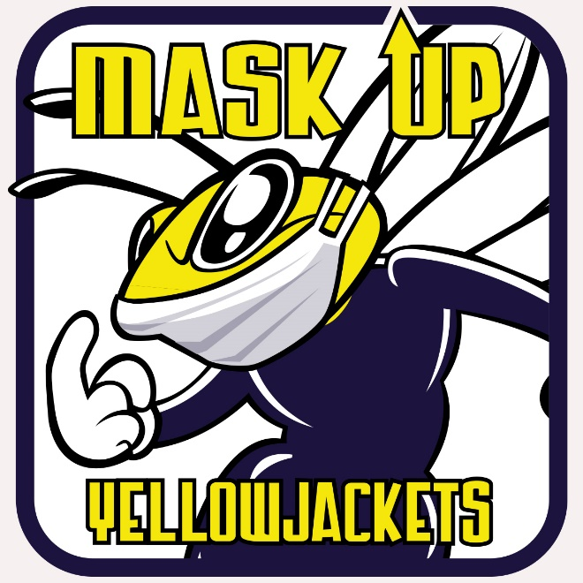

Overview of Remote Learning

Elementary:

Grades K-3:

Students in these grades may participate in some synchronous class meetings (student and teacher work together at the same time in on online classroom) or teleconferences, and asynchronous (students completing learning activities on their own) learning activities each day between 8:00 am-2:00 pm.

Students will receive instruction focused on English Language Arts (ELA) and Mathematics, social studies, science, with supplemental lessons in physical education, and other content areas including music, art, and technology.

Students will be asked to participate in check-ins with their teacher and will complete teacher-directed activities as well as prerecorded lessons and activities that will be available on an online learning platform. Student schedules for remote learning will be provided prior to beginning of instruction.

Grading procedures for remote learning will be the same as outlined in the district grading policy.

Students in these grade levels will need to have access to a parent or other adult to act as a learning coach from home each day. Parent involvement will be imperative in order to ensure that instruction is meeting the needs of the student. Teachers will communicate with parents/students on a regular basis in order to monitor progress.

Grades 4-6:

Students in these grades will participate in some synchronous class meetings (student and teacher work together at the same time in an online classroom) and/or teleconferences and asynchronous learning activities (students completing learning activities on their own) each day between the hours of 8:00 a.m. and 2:00 p.m.

Students will receive instruction in English Language Arts (ELA), Mathematics, Social Studies, Science, Physical Education and special courses.

Students will be asked to participate in daily check-ins with their teacher and will complete assignments that will be available on an online learning platform using Microsoft TEAMS. Student schedules for remote learning will be provided prior to beginning of instruction.

Grading procedures for remote learning will be the same as outlined in the district grading policy.

Teachers will communicate with parents/students on a regular basis in order to monitor progress.

Parent involvement will be imperative in order to ensure that instruction is meeting the needs of the student.

Middle School:

Grades 7-8:

Students in these grades will participate in some synchronous daily class meetings (student and teacher work together at the same time in an online classroom), and/or teleconferences, and asynchronous learning (students completing learning activities on their own) activities each day between the hours of 8:00 a.m. and 2:00 p.m.

Students will participate in two courses per grading period. Content covered throughout the length of the semester will include i.e. English Language Arts (ELA), Mathematics, Social Studies, Science, and other exploratory/elective courses.

Students will be asked to participate in daily check-ins with their teacher and will complete assignments which will be available on an online learning platform using Microsoft TEAMS. Student schedules for remote learning will be provided prior to the beginning of instruction.

Grading procedures for remote learning will be the same as outlined in the district grading policy.

Teachers will communicate with parents/students on a regular basis in order to monitor progress.

Parent involvement will be imperative in order to ensure that instruction is meeting the needs of the student.

High School:

Grades 9-12:

Students in these grades will participate in some synchronous daily class meetings (students and teachers work together at the same time in an online classroom) and/or teleconferences and some asynchronous learning (students completing learning activities on their own) activities each day between the hours of 8:00 a.m. and 2:00 p.m.

Students will participate in two courses per grading period. Content covered throughout the length of the semester will include English Language Arts (ELA), Mathematics, Social Studies, Science, Health Enhancement, Art, Music, Foreign Language, CTE and other elective courses.

Students will be asked to participate in daily check-ins with their teacher and will complete assignments that will be available on an online learning platform using Microsoft TEAMS. Student schedules for remote learning will be provided prior to beginning of instruction.

Grading procedures for remote learning will be the same as outlined in the district grading policy. Teachers will communicate with students/parents on a regular basis in order to monitor student performance.

Parent involvement will be imperative in order to ensure that instruction is meeting the needs of the student.

Attendance:

Attendance will be taken for all students participating in remote learning instruction. All students will be required to attend remote learning instruction on a daily basis. Daily check ins and/or TEAMS meetings will be scheduled individually by each teacher. It will be the responsibility of the student to check in at the scheduled time.

Parents will need to report students off for any day that they will not be participating in remote learning.

Remote Learning Calendar:

The remote learning calendar will follow the 2020-2021 Butte School District School Calendar. Beginning August 31st, teachers will begin contacting students/families to provide more detailed information regarding the remote learning daily schedules. Please note the first day of instruction for remote learning will be September 8, 2020.

Access to Technology:

Students may check out computers to use while enrolled in the remote learning. Additionally, students who do not have access to the internet may check out a “hotspot” device for internet access. Students/families should contact their school to obtain the loan agreement. Completed forms should be submitted to the building principal. Additionally, students will need to sign and submit to their principal the District’s internet and network usage policies.

**Structure:**

Butte School District will be utilizing a hybrid model of on-line programs/communications as well as traditional paper/pencil activities to provide off-site learning for its students.   The hybrid model will ensure that content and services are equitable for all students regardless of limited resources at home.

**Instruction:**

**K-12 on-line Learning Platform – Microsoft Office 365 - TEAMS**

 Butte School District K-12 teachers will be providing remote learning using the Microsoft TEAMS platform. Teachers will also be using the TEAMS platform to upload prerecorded lessons, post assignments, and administer tests. Additionally, teachers and students may also use TEAMS to conduct synchronous meetings and/or daily check ins.

In addition to using the Microsoft TEAMS platform students will have access to a variety of software applications and resources via their Classlink account. The following is a list of some of the applications and resources that are available to students:

* Infinite Campus Student Portal
* On-line textbooks
* Freckle
* Math 180
* Office 365
* Lexia: Special Education Literacy
* Project Lead the Way
* Accelerated Reader
* Study Sync: 7-12 English
* Think Central:  K-6 Go Math
* Typing Instructor
* World Book: research data base
* EBSCO: research data base
* Destiny: Library
* Software including EBooks
* GradPoint
* Lexia: Special Education Literacy Program

Services for Students with a Disability:

Butte School District, in compliance with IDEA and Section 504, will provide in -person and/or remote delivery of a free and appropriate public education (FAPE) all students eligible IDEA and/or 504 students. Students with special needs will be provided special education and related services via in- person instruction and/or remote learning using a variety of models that include in-person instruction, video and/or telephone conferencing, online, paper and pencil packets and adaptive technologies based on the individual needs of each student.

The Butte School District special education instructional staff and support personnel will continue to monitor progress on IEP goals throughout all phases of the reopening plan. Based on these results, the District “will make a determination whether and to what extent compensatory services may be needed for each individual student. These compensatory services consistent with applicable requirements, will include the remediation of any lost skills brought on by the school closure.

Butte School District will conduct ER/IEP meetings using Microsoft TEAMS and/or conference telephone calls. Copies of the document will be provided to parents ten days in advance and will include an additional signature page to be returned documenting their participation.

Butte School District will continue to provide services to identified homeless students. Families will be contacted by the instructional staff to ensure they have transportation for in-person instruction or if enrolling in remote learning that they have access to the appropriate remote learning materials. Additionally, the Butte School District will continue to provide free breakfast and lunch to homeless students. Grab-n-Go breakfasts and lunches will be available at all Butte School District schools including those enrolled in remote learning. A schedule for pick-up of lunches for remote learners will be posted on the website for each school.

Butte School District utilizes a web content platform that is compliant with all ADA accessibility guidelines as outlined by the Office of Civil Rights.

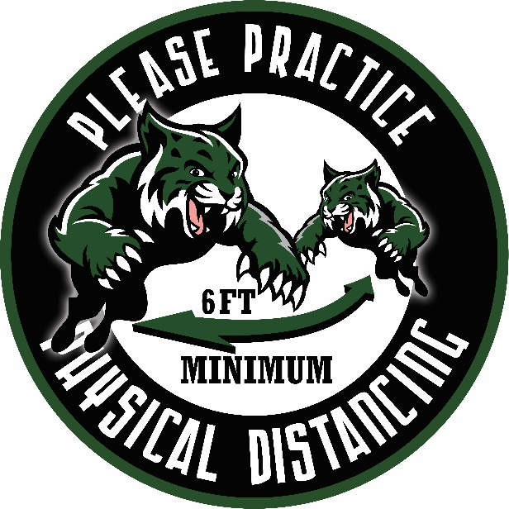

Support Services:

The Butte School District will continue to provide support services to all K-12 students. These services will be available to students and families who have enrolled in remote learning.

School Nurses:

The Butte School District nursing staff will be the point of contact for all teachers and students at each school regarding COVID-19 related issues. Families are asked to contact the school nurse regarding any questions relating to COVID-19. Normal screenings that occur each year have been changed and specific updates on this information can be found under the health and wellness section.

School Counselors:

School guidance counselors and nurses will continue providing support and services through phone calls, emails, or Office 365 TEAMS video conferences. Students who regularly worked with school counselors will be contacted weekly to continue providing supports.

Tier II Intervention Specialists

Butte School District employs four social emotional tier 2 support/intervention specialists. These specialists work with students in each of our schools. The team will continue working with students on its caseload who have opted for remote learning through weekly meetings. These meetings will be conducted through Office 365 TEAMS video conferences or by phone call.

CSCT (Comprehensive School and Community Treatment) Programs.

Comprehensive School and Community Treatment Programs will be available for students enrolled in both in -person instruction or remote learning. Providers will continue providing treatment for K-12 students via in-person sessions and/or Telehealth or Zoom meetings. Providers will be working with students one on one to assist them in achieving established goals.

Students in Crisis

For students deemed to be in crisis, Butte School District will utilize our established protocols and policies for working with families and students in crisis. These supports will be available for all students enrolled in either the in-person instruction or remote learning. School Resource Officers are available to assist with wellness checks, and if necessary, students will be referred to the local crisis response team at St. James Healthcare.

Additionally, all school counselors and tier 2 support specialists have been trained in Connect Butte. Connect Butte is an electronic based consented referral system. Students can be referred for needed services through this system.

Progress Monitoring

Butte School District

Determining Operational Phases within the Butte School District Reopening Plan

The Butte School District Reopening Plan includes a three- phased plan with an additional 100% remote learning option if schools are closed by order of state directives or if local situation is such that in- person instruction would cause a significant risk to the overall health of the Butte community.

Phases I and II are the most restrictive plans with students attending school in cohorts with a modified daily schedule. Phase I: students would attend school on an A/B schedule and remain in their cohort and modified daily schedule. Phase II: all students would attend everyday within their scheduled cohorts and with a modified daily schedule. (See Attached 3-Phased Plan)

Determining which phase to reopen schools or continue within a specific phase will be based on any new state directives, but more importantly, it will be dependent upon the community spread of COVID-19 and the district’s ability to staff all classrooms.

The monitoring process will require continuous communication between the Butte Silver Bow Health Department and Butte School District. The communication will include an analysis of the most current data relating to the virus and recommendations for school operations. Based on this review the recommendations for any changes in phases will be communicated immediately to the Board of Trustees. Additionally, the weekly data from the Butte Silver Bow Health Department will be forwarded to all members of the Butte School District Board of Trustees. Families and staff will be notified immediately of any changes of a school closure or if a cohort/classroom has to go remote. This information will be sent out as soon as possible with the understanding that the district will need to act quickly and decisively in order to keep staff and students safe. Families should be aware that schedules can change quickly and we must be flexible in moving to remote learning. The district will notify parents no later than 6:00 am if schools have to be closed or if a cohort/classroom has to go remote. Families and students will receive this communication via the District’s Shoutout messaging system and changes will also be posted on our website. Butte School District will send out a press release notifying the local media of these schedule changes.

The Butte School District Crisis Management Team will be responsible for progress monitoring and communicating with the Butte Silver Bow Health Department. This team will also be responsible for notifying any operational changes to board members, staff, families, and students.

This same process will also be used to determine movement into Phase 3, the least restrictive phase of the Butte School District Reopening Plan.

The Process

This chart provides a brief summary of the level of mitigation that is needed based on the level of community transmission. The chart is used by the Butte Silver Bow Health Department to communicate the level of mitigation that is required based on current status of the virus in Butte Silver Bow County. Based on the level of community transmission the Butte Silver Bow Health Department will determine the level of mitigation and make recommendations regarding the appropriate operational phase that the District should be implementing.

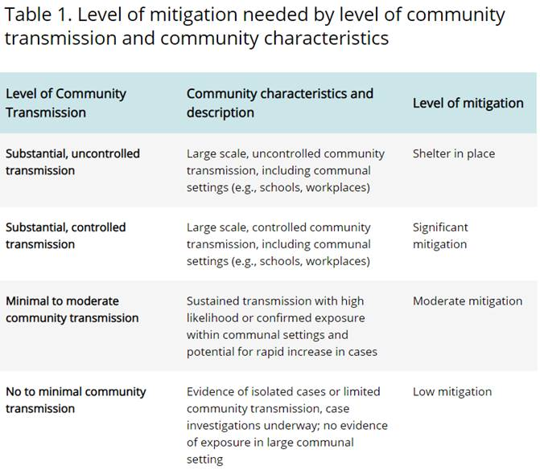

*\*Taken from the CDC*

Positive Cases Reported:

The following chart will be used as a *guide* in collaboration with the Butte Silver Bow Health Department to make recommendations for the level of mitigation needed based on the number of positive cases reported. Please note that each positive case reported is unique and responses may differ from what is listed on this chart depending on the situation.

|  |  |  |  |  |  |  |  |
| --- | --- | --- | --- | --- | --- | --- | --- |
| **Level of Community Spread based on State and Local Public Health** | **Criteria 1**  **1 student or staff members at one site OR 1 student or staff in multiple sites in different clusters** | |  | | --- | | **Criteria 2**  **2-4 Students or staff members at one site *OR* 2-4 Students or staff members at multiple sites in different clusters** | | |  | | --- | | **Criteria 3**  **5+ students or staff members at one site *OR* in one cluster** | | |  | | --- | | **Criteria 4**  **5+ students or staff members in multiple clusters** | |
| **Low**  **No Spread** | Close school for up to 24 hours | |  | | --- | | Close  school(s)  72-hours (minimum) | | |  | | --- | | Close individual school or cluster for 14 days (minimum) | | |  | | --- | | Close district for 14 days (minimum) | |
| **Moderate** | Close school for up to 24 hours | |  | | --- | | Close school(s) for 72-hours (minimum) | | |  | | --- | | Close individual school(s) or cluster(s) for 14 days (minimum) | | |  | | --- | | Close district for 14 days (minimum) | |
| **Substantial** | Close school for up to 72 hours | |  | | --- | | Close school district for 72-hours (minimum) | | |  | | --- | | Close district for 14 Days (minimum) | | |  | | --- | | District Closed indefinitely  Based on the guidance from State/local health officials. | |

*Please note: All school closures will be based on the recommendation of the Butte Silver Bow Health Department. (Based on Fulton County Mitigation Chart)*

Determining Individual School Operations based on certified staffing level within Butte School District schools/buildings.

|  |  |  |  |
| --- | --- | --- | --- |
| **Absences** | **COVID Related Absences** | **COVID POSITIVE REPORT** | **Non COVID Related Absences** |
| **School Criteria** | Teachers on mandated quarantine. (Having close contact with a person testing positive). No impact to cohort | Report of positive case among certified staff. | Daily absences not relating to COVID 19 |
| **Building Certified Staff available for coverage for quarantined teachers and non-related absences** | Continue with normal operations | See Butte Silver Bow Health table to determine mitigation level. | Continue with normal operations. |
| **Substitute available to cover teachers for length of absence.** | Continue with normal operations. | See Butte Silver Bow Health Table to determine mitigation level | Continue with normal operations. |
| **Coverage is not available for teachers on quarantine** | Cohort transitions to remote learning/ regular/quarantined teacher provides the instruction | Cohort transitions to remote learning. Remote learning duties will be assessed and substitute will be provided if regular teacher is unable to provide remote learning. | School continues to operate with the exception of the cohort that has transitioned to remote learning. |
| **Coverage is not available for quarantine teachers or coverage for non-related absences** | Cohort transitions to remote learning with regular teachers providing instruction for a minimum of 14 days. | Cohort or entire school transitions to remote learning (See Butte Silver Bow Health Table). Remote learning duties will be assessed and a substitute will be provided if regular teacher is unable to resume remote duties. | Cohort or school (depending on number) transition to remote learning with regular teachers providing instruction for a minimum of 14 days or until staffing levels return to normal levels. |

Butte Silver Bow County/Butte School District Process:

* The Health Department management staff will meet every Monday morning to discuss the data from the week prior (again, Saturday through Friday), to update our data and graphs and to send that updated information to Superintendent. Butte School District will receive this information every Monday, probably mid-day.
* If Butte Silver Bow starts to have numerous cases within the district or in the wider community, the health department will contact the District immediately. Collaboratively Butte Silver Bow Health Department and Butte School District can discuss and prescribe a course of action as outlined in the Butte Silver Bow Health Department guide.
* Butte School District nurses will be the point of contact for students and staff regarding COVID-19 related issues. Positive reports will be communicated to the Butte School District via the nurses. Follow up to notification will be completed by the nurses and/or Human Resource Department.
* Students and staff are asked to report immediately to their school nurse regarding COVID-19 related issues. Students and staff will be surveyed regarding absences in order to track the District status as it relates to COVID-19
* If a student or staff member tests positive for COVID-19, Butte School District # 1 staff and the Butte Silver Bow Health Department will collaborate to effectively manage and investigate the case while maintaining the safety of students and staff. Each case is unique and actions taken will be carried out on a case by case basis. Butte School District # 1 will adhere to the advice and directives of the health department staff conducting the investigation. Health care professionals from the Butte Silver Bow Health Department will guide affected individuals and schools with contact tracing, the need to quarantine, follow up with health care providers, retest for COVID-19 if necessary, and advise as to when it is safe to return to school or work. Classroom or school closures may be indicated and will be adhered to as advised by the Butte Silver Bow Health Department to Butte School District #1.

|  |  |  |  |
| --- | --- | --- | --- |
| **Date** | **R0** | **Positivity Rate** | **Level of Community Spread** |
| 8/10/2020 | .49 | 1.9% | Minimum/Moderate |
|  |  |  |  |
|  |  |  |  |

* Butte-Silver Bow estimates current R0 of .49, which means each of our infections caused less than one new infection. Though the health department has declared community spread, the current R0 value indicates that the county is still able to manage COVID-19 in Butte-Silver Bow.
* The Butte Silver Bow Health Department currently has determined that Butte-Silver Bow to be in **Minimal to Moderate community Spread**, which means moderate mitigation is required. Butte Silver Bow Health Department therefore “believes the district’s plan to reopen in Phase II (of your three-phase plan, second attachment), is prudent.”

Health and Safety Protocols:

COVID-19 Reporting:

* Butte School District instructs anyone with symptoms to contact their health care provider or Southwest Montana Community Health Center. If someone tests positive to COVID-19, the Butte Silver Bow Health Department will contact the patient with additional information.
* 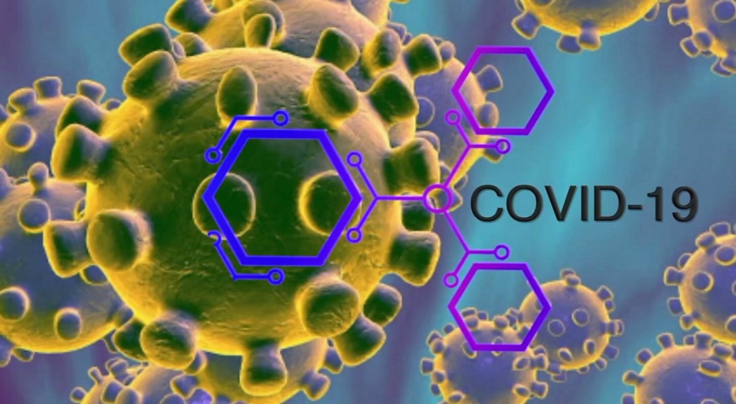The Health Department will contact anyone that is considered to have been in close contact with the individual who tests positive. Anyone who has had close contact with the person will be contacted by the Butte-Silver Bow Health Department. The employee should not take any further action. Please remember that this information is considered confidential and should not be shared with the class or anyone else.
* In the event that there is a positive test in a classroom, the classroom will be closed off until sanitization and disinfection is completed. If an empty classroom is not available that class, cohort, or entire school may need to move to a remote learning environment until the disinfection routine is completed. All stakeholders will be notified as soon as possible in the event that we need to move to a remote learning environment.
* In the event that one or more individuals become sick, and sufficient personnel is not available to continue with in person learning the class or cohort may need to move to a remote learning environment. All stakeholders will be notified as soon as possible in the event that we need to move to a remote learning environment.
* The Health Department will contact anyone that is considered to have been in close contact with the individual who tests positive. A close contact is someone who was within 6 feet of an infected person for at least 15 minutes, starting from two days before the onset of the illness. Close contacts of asymptomatic patients are identified as those who were close to the asymptomatic individual two days prior to a specimen collection that is positive, and until the time the patient is isolated.

****Close Contact:****

A close contact is someone who was within 6 feet of an infected person for at least 15 minutes, starting from two days before the onset of the illness. Close contacts of asymptomatic patients are identified as those who were close to the asymptomatic individual two days prior to a specimen collection that is positive, and until the time the patient is isolated.

A close contact can also be defined as:

* Someone who took care of a person at home who is sick with COVID-19
* Someone who had direct physical contact with the infected person (touching, hugging, kissing)
* Someone who shared eating or drinking utensils with the infected person
* Someone who is the recipient of respiratory droplets from the infected person, via sneezing or coughing

Once the Health Department is notified by the state that a person is confirmed as positive, the health department will work with that individual on isolation measures. The health department also works with that person to identify his or her close contacts. Then the health department works with those close contacts to quarantine and get tested. The identity of the person who tested positive is confidential and will not be released to others, not even those who are close contacts. When the Health Department reaches out to the close contact they just inform the person that they have been identified as a close contact by a patient but they do not release the name. The individual who is confirmed positive may share with others if they choose.

If someone is associated with a confirmed case of COVID-19, that person would not need to worry about being a close contact, unless they are contacted by the Health Department and informed that they are a close contact. Secondary contacts and more remote contacts would not be contacted by the department and therefore do not need to take any action nor quarantine. They would continue to proceed as normal.

If you are notified by an agency or an individual not associated with the Butte-Silver Bow Health that you are a close contact, please contact the Butte-Silver Bow Health Department immediately. The Health Department will confirm that you are a close contact.

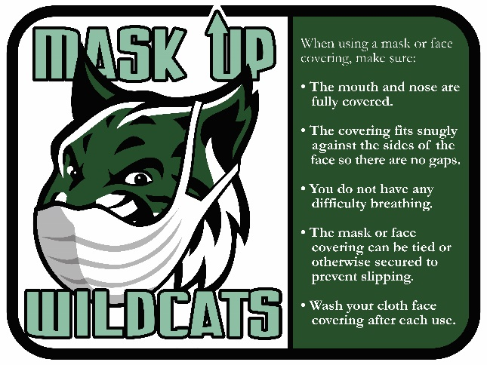

Face Coverings/Masks

Students, teachers and support staff will be provided a face covering and a face shield at no cost. They are available at your individual building. Teachers will have the option to wear face shields, if they maintain physical distancing while lecturing or a face covering in the classroom while teaching. Face shields may be useful for teachers because students can more easily read lips and observe facial expressions. However, once the teacher or support staff leaves the instructional environment, a face covering must be used. The face shield is only to be used if there is a medical need and a special accommodation has been approved by Human Resources. Staff members who wish to use a face shield must also have a medical need and work with Human Resources.

Each District building will stock an ample supply of disposable masks that will be available to all district employees.

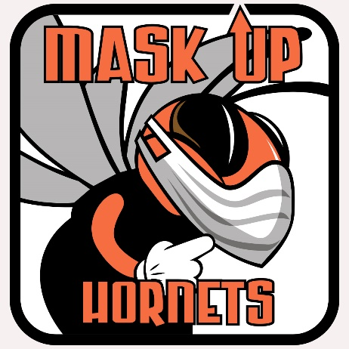Physical Distancing/ Social Distancing:

Butte School District will adhere to the social distancing recommended by the CDC to the extent possible. In areas where physical distancing is impossible the Butte School District students and staff will be required to wear masks.

Isolation of a Student or Staff Member Symptomatic of COVID 19

All students and staff members are to wear face coverings in the school setting. Visitors to the school setting are discouraged but when an individual who is not a student or staff member must be present in the school setting, they too are required to wear a face covering.

Isolation per CDC Guidance separates sick people with an actual or perceived contagious disease from people who are not sick

School Nurses will work with administrators of student occupied school buildings to evaluate the current health office designated space and determine if there is adjacent or nearby space for isolation.

If an adjacent or nearby space is not available, consideration will be made to move the health office work area to another larger location with a separate adjacent space. Attention will be paid to ventilation such as windows and proximity to an outside door to reduce the spread of disease for isolated individuals exiting the building. Computer, phone, internet and restrooms with handwashing or hand sanitizing facilities are a priority in the designated health office space as the situation allows. The health office for ill students or staff members will be different from the area injured (non- ill) students or staff report to for basic first aid or for daily or as needed wellness procedures including but not limited to ordered medications or medical procedures to maintain optimal health.

If a student or staff member presents with a fever of 100 degrees F or >, they will be directed to leave the building as quickly as possible. If a student or staff member is feeling ill but does not have a fever >100, but has 2 or more symptoms including cough, shortness of breath, difficulty breathing, chills, muscle pain, headache, sore throat, new loss of taste or smell, nausea, vomiting, stomach ache, fatigue or diarrhea they will also be directed to leave the school building as quickly as possible. If these symptoms are explainable by an underlying condition (such as shortness of breath or cough for an individual with asthma) exclusion from school may not be necessary. Staff and students who are licensed drivers, have their vehicle on site and feel well enough to drive home will do so immediately.

If an ill staff member or student cannot leave immediately for various reasons, that individual will be provided a medical grade mask to replace or wear over their existing face covering. If the individual must remain at school for 15 minutes or longer, they may be allowed to wait outdoors (weather permitting, with staff observation) or they will be directed and assisted if needed to an isolation pod. The pod will be in an area where the ill individual can be visually observed by a school district employee. The isolation pod must be a minimum of 6 feet away from all other individuals. The area housing the affected individual in the pod should then be as closed off as the situation allows so that no others enter the area. The staff member observing the affected individual may be the school nurse (when present) or another educated staff member who assists ill students in the absence of the school nurse. School staff members observing the ill student or staff member may need to use additional PPE including a medical grade mask, gloves, face shield or other protection that covers the eyes and a gown that covers the individuals clothing if assistance or contact less than 6 feet is necessary.

Every effort will be made to minimize the amount of time an ill person remains in the school building and distant observation of 6 feet or greater will be adhered to as the situation allows.

Once the ill student of staff member leaves the building- the area(s) the ill person occupied will be cleaned and disinfected by trained and qualified employees. Staff members cleaning and disinfecting will remain in full PPE mentioned earlier during clean up.

If an isolation pod is used, wait 24 hours to clean and disinfect the used pod. A used pod may be relocated to an area with little or no human traffic and open outside doors and windows to increase air circulation in the area. The person relocating the used pod will remain in full PPE while relocating the pod. If waiting 24 hours is not feasible, wait as long as possible to clean and disinfect.

Following complete cleaning and disinfecting, gloves and disposable medical masks will be disposed of in a trash bag and tied shut. The fabric gown will be removed, bagged, and laundered as quickly as possible. Thorough hand washing will be complete and the reusable face shield will become the property of the staff member, cleaned with appropriate anti-microbial anti-viral cleaner and marked with the person’s name and set aside in a secure location for future use by that individual only. Otherwise it must be properly disposed of as mentioned above.

Non- disposable Items that cannot be cleansed and disinfected (e.g. paper, books, and school supplies) should be removed from the classroom and sealed in an air tight container for a minimum of 10 days

Students or staff excluded for these symptoms should not return until they have either tested negative for COVID-19 , a medical examination determines that their symptoms were due to another cause, or their health care provider or local health department staff provides notification that they are no longer considered contagious and may safely return to the school setting. Written or faxed notes for return from health care providers will be accepted by the school district for students and staff members.

For students or staff members who go home ill and do not test positive for COVID -19 or who are not diagnosed with any other communicable disease are to remain home until all symptoms of illness subside and all individuals should be free of any fever for 48 hours WITHOUT the use of any fever reducing medications.

Schools are not expected to screen students or staff to identify cases of COVID 19. If a student or staff member tests positive for COVID-19, Butte School District # 1 staff and the Butte Silver Bow Health Department will collaborate to effectively manage and investigate the case while maintaining the safety of students and staff.

Home Health Screening:

Parents/Guardians,

Due to the current pandemic from Coronavirus or Covid-19 our school year will look significantly different. We are taking all measures to ensure the safety of our students and staff. In order to do this, we need your help! Controlling the spread of Covid-19, ensuring school health while still providing the best education to our students is our priority. This form is an explanation of expectations and an agreement of understanding. Please read through this information, complete, sign, and then return to school with your child.

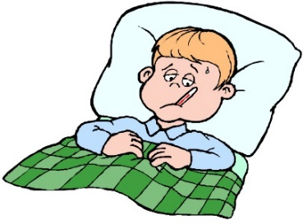When to keep your child home

*\*\*\*Current fever or fever (temperature higher than 100.0) within the last 48 hours\*\*\**

2 or more of the following symptoms…

* *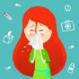Fever (>100.0) or chills*
* *Shortness of breath*
* *Cough*
* *Runny Nose*
* *Fatigue or achy*
* *Loss of taste or smell*
* *Nausea/vomiting/diarrhea*
* *Rash to hands or feet*

Please do not medicate your child with fever reducing medication and send them to school if they wake up with a fever in the morning!

In the event that your child has any of the above symptoms accompanied by a fever at school, you will be called and your child will need to be picked up as quickly as possible. If your student must wait 15 minutes or more, they will be given a medical grade mask and may be placed in an isolation tent where they can be monitored by the school nurse (if present or other school personal, i.e. secretary), or they may wait outdoors, weather permitting, with staff observation.

In the event that a direct contact family member, parent/guardian, or student test positive for Covid-19, your child will not be allowed to return to school until cleared by their physician.

Student Name: __________________________­­­­­­__

Parent Signature: __________________________

Date: ­­­­­­­­­­­­­­­­­­­­­­­___________________________________

Butte School District Cleaning and Disinfecting Plan:

Routine Cleaning and Disinfection Practices:

1. Normal routine cleaning with soap and water will decrease how much of the virus is on surfaces and objects, which reduces the risk of exposure.
2. Disinfection using EPA-approved disinfectants against COVID-19 can also help reduce the risk. Frequent disinfection of surfaces and objects touched by multiple people is important.
3. When EPA-approved disinfectants are not available, alternative disinfectants can be used (for example, 1/3 cup of bleach added to 1 gallon of water, or 70% alcohol solutions). Do not mix bleach or other cleaning and disinfection products together--this can cause fumes that may be very dangerous to breathe in. Keep all disinfectants out of the reach of children.

Basic Information and PPE Protocols:

1. Coronaviruses on surfaces and objects naturally die within hours to days. Warmer temperatures and exposure to sunlight will reduce the time the virus survives on surfaces and objects.
2. Normal routine cleaning with soap and water removes germs and dirt from surfaces. It lowers the risk of spreading COVID-19 infection.
3. Disinfectants kill germs on surfaces. By killing germs on a surface after cleaning, you can further lower the risk of spreading infection. EPA-approved disinfectants are an important part of reducing the risk of exposure to COVID-19.
4. Store and use disinfectants in a responsible and appropriate manner according to the label. Do not mix bleach or other cleaning and disinfection products together--this can cause fumes that may be very dangerous to breathe in. Keep all disinfectants out of the reach of children.
5. Always wear gloves appropriate for the chemicals being used when you are cleaning and disinfecting. Additional personal protective equipment (PPE) may be needed based on setting and product.
6. Practice social distancing, wear facial coverings, and follow proper prevention hygiene, such as washing your hands frequently and using alcohol-based (at least 60% alcohol) hand sanitizer when soap and water are not available

Determine what needs to be Cleaned:

1. Some surfaces only need to be cleaned with soap and water. For example, surfaces and objects that are not frequently touched should be cleaned and do not require additional disinfection.
2. See cleaning checklist to identify cleaning routines based on use.

Determine what needs to be disinfected:

1. Following normal routine cleaning, you can disinfect frequently touched surfaces and objects using a product approved by the EPA.
2. Examples of frequently touched surfaces and objects that will need routine disinfection following reopening are: (i.e. tables, • doorknobs, • light switches, • countertops, • handles, • desks, • phones keyboards, • toilets, • faucets and sinks) Each school and/or classroom will have different surfaces and objects that are frequently touched by multiple people which will need disinfecting

Clean surfaces and objects using soap and water prior to disinfection.

1. Always wear gloves appropriate for the chemicals being used for routine cleaning and disinfecting.
2. Follow the directions on the disinfectant label for additional PPE needs.
3. When you finish cleaning, remember to wash hands thoroughly with soap and water.
4. Clean or launder soft and porous materials like seating in an office or, area rugs, and carpets.
5. Launder items according to the manufacturer’s instructions, using the warmest temperature setting possible and dry items completely. earn visibly dirty surfaces with soap and water

Use the appropriate cleaning or disinfectant product

1. Use EPA approved disinfectant product for use against COVID-19 and follow directions on the label including concentration, dilutions, application method, contact time, and other special considerations when using the product. (See Six Steps for using Disinfectants)

Cleaning Electronics

* Follow the manufacturer’s instructions for all cleaning and disinfection products.
* Use wipeable covers for electronics.
* If no manufacturer guidance is available, consider the use of alcohol-based wipes or sprays containing at least 70% alcohol to disinfect touch screens. Dry surfaces thoroughly to avoid pooling of liquids.

Cleaning and Disinfecting Outdoor Areas:

1. Playground equipment require routine cleaning. (Do not spray disinfectant on outdoor playgrounds- it is not an efficient use of supplies and is not proven to reduce the risk of COVID-19

* High touch areas made of metal or plastic such as grab bars, and railings should be cleaned routinely after use.
* Disinfection of wooden surfaces is not recommended.

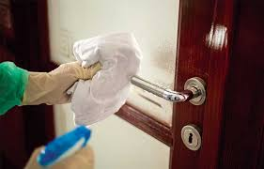

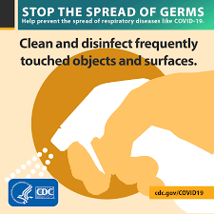

Cleaning and Disinfecting Butte after Report of Illness due to COVID -19

1. Wait 24 hours before you clean or disinfect. If 24 hours is not feasible, wait as long as possible.
2. Open outside doors and windows to increase air circulation in the area.
3. Clean and disinfect all areas used by the person who is sick, such as offices, bathrooms, common areas, shared electronic equipment (i.e. computers keyboards, phones, remote controls)
4. Vacuum the space if needed. Use a vacuum equipped with high-efficiency particulate air (HEPA) filter, if available.

* Do not vacuum a room or space that has people in it. Wait until the room or space is empty to vacuum, such as at night, for common spaces.
* Wear disposable gloves to clean and disinfect. For soft surfaces such as carpets or rugs clean the surface with detergents or cleaners appropriate for use on these surfaces, according to the textile’s label. After cleaning, disinfect with an appropriate EPA registered disinfectant.
* Soft and porous materials, like carpet, are generally not as easy to disinfect as hard and non-porous surfaces. EPA has listed a limited number of products approved for disinfection for use on soft and porous materials on List N. Follow the disinfectant manufacturer’s safety instructions (such as wearing gloves and ensuring adequate ventilation), concentration level, application method and contact time. Allow sufficient drying time if vacuum is not intended for wet surfaces.
* Temporarily turn off in-room, window-mounted, or on-wall recirculation HVAC to avoid contamination of the HVAC units.
* Do Not deactivate central HVAC systems.
* Turn off room fans so that particles that escape from vacuuming will not circulate throughout the facility.

1. Once area has been appropriately disinfected, it can be opened for use.

* Workers without close contact with the person who is sick can return to work immediately after disinfection.

Please Note: If more than 7 days since the person who is sick visited or used the facility, additional cleaning and disinfection is not necessary. Continue with everyday cleaning and disinfecting.

Cleaning:

1. Regular cleaning staff can clean and disinfect community spaces.
2. Wear disposable gloves, masks, and gowns for all tasks in the cleaning process, including handling trash. (Include training on proper procedures for removing gloves and gowns.)
3. Wash hands often with soap and water for 20 seconds. Always wash hands after removing gloves, masks, and gowns.

Procedures/ Protocols for Specific Areas in District Facilities:

*Classroom Set-up:*

* Desks should be facing one direction. (If tables are being used students should only sit on one side of the table). Consider replacing tables with individual desks.
* Student textbooks/ materials should be stored in their own desk/container
* Eliminate all large group circle time on classroom carpets.
* Provide each student with their own supplies, do not share materials. If using manipulatives consider using individual bags containing the manipulatives that will be needed for the lessons.
* Art supplies, music supplies should not be shared.
* Keep windows open for ventilation. (If applicable)
* Classroom computers should be wiped down after each use.
* Consider reducing the movement among students in the classroom in order to maintain social distancing.
* Limit the number of students using the Smartboard/white board at one time.
* Instructional groups should be spaced in order to physically distance as much as possible.
* Schedule periodic times for hand washing, sanitizing. These should be scheduled throughout the day as many times as possible.
* If using laptops, make sure students are assigned the same computer each day and that all computers are sanitized after every use.
* Place informational signage throughout the classroom relating to hand washing, social distancing, and wearing masks.
* Floors should be marked to remind students to social distance and provide a route for traffic flow that allows for the best distancing as possible.

*Hallways:*

* Water fountains should not be used and should be covered.
* Signage on social distancing and traffic flow should be in all hallways.
* Limit the number of students in the hallway at any one time. This will require staggering recess and bathroom breaks.
* As much as possible try and keep the same students in the same area of the school each day. When transitioning to recess or dismissing try and create outside pathways for transitioning.

Lunch Rooms:

* Grab-n-Go lunches will be provided. Students will eat in classroom.
* Masks are not required when eating or drinking.
* Classroom desks, tables must be disinfected and wiped down after lunch.
* Trash from lunch will be placed in a large garbage receptacle and set outside each classroom for pick-up

Gymnasiums:

* Provide physical guides, such as signs, paint and tape on floors or playing fields
* Focus on individual skill building versus competition
* Space players at least 6 feet apart on the field, when possible, while participating in the sport (such as during warmup, skill building activities and simulation drills).
* Consider using outdoor areas for instruction when weather permits.
* Equipment must be disinfected and sanitized between different groups. Consider planning activities that do not require the use of equipment.
* Additional time between groups must be provided so that area can be disinfected as well as any equipment and other cleanable surfaces before the next class begins.
* Create cohorts within the class to reduce exposure risk.
* Post appropriate signage in all areas of the gymnasium directing traffic, social distancing, and proper procedures for hand washing and wearing masks.
* Hand sanitizer stations should be placed at entrance of gymnasium.

Locker Rooms/Lockers:

* Students will not store equipment or personal items in lockers or in locker rooms. All equipment and personal items need to be taken home nightly.
* Close shared spaces such as locker rooms, if possible; otherwise, stagger use clean and disinfect between use.
* All social distancing requirements must be observed.

School Offices:

* Install physical barriers, such as sneeze guards and partitions, particularly in areas where it is difficult for individuals to remain at least 6 feet apart (e.g., reception desks).
* Place hand sanitizer and masks in an open area outside the office area in the event a student, teacher or other essential workers do not have a face covering.
* Place signage to direct flow of traffic, informational posters for social distancing, proper procedures for wearing a mask, and hand sanitizing.
* Develop procedures for dropping off and picking up materials that will reduce congestion in the office. Consider having containers located outside of office to drop off material. Consider different procedures for reporting to work in order to reduce congestion in offices.
* Post entrances and exits for each grade level in the main office.
* Hand sanitizer stations should be placed outside of office doors.
* Consider limiting access to office phones.
* Disinfect and sanitize all office equipment after every use.
* Consider using gloves when using office equipment and machines.

Water Fountains

* Sensored water stations can be used however, maintain social distancing and create schedules to use the stations in order to reduce congestion in the hallways.
* All drinking water fountains should be covered and not used.

Ventilation:

* All new filters have been placed in all schools and buildings and replacement schedules have been developed for all district facilities.

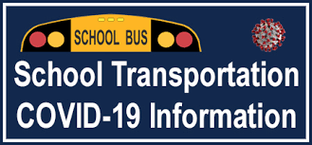

Capacity/ Bus Safety Protocols

* The Butte School district will limit capacity on our Buses.
* Pupil walk zones will be extended for all grades, this will be within compliance of OPI regulations.
  + - * + Elementary schools will be one mile from the school,
        + Middle School will be two miles, and
        + High School will be three miles.
* Capacity on the school bus will be limited to one student per seat. These students will also be required to sit in an alternating pattern. Example: first row sits near window; second row sits near isle. Once capacity is reached on a route, these students will be transported to school. -
* When planning our bus routes, we will be picking students up that are furthest away from a particular school.
* Families are encouraged to transport their students to school.
* Assigned seats will be required. This will be configured on the order of pickup of the students. Example: Students picked up first will be assigned in the back of the bus and students picked up last will be in the front. Likewise, in the afternoon, students on the last bus stop will be assigned to the back of the bus.
* Masks will be required for all students to ride the bus.
* As students enter the bus, they will be required to use the hand sanitizer that is stationed at the front of the bus.
* During the warmer months, we will open every other window two inches. This will allow for proper air flow through the bus.
* No food or drink will be allowed consumed to be on the bus at any time. This includes items from the school or home. Items need to be stored in backpacks or lunchboxes.
* Buses will be disinfected after completing each route.

Please note the transportation plan may change depending on recommendation and guidance from the Butte Silver Bow Health Department. Any changes to these procedures will be posted on the District’s website and families will be notified as soon as possible.

Butte School District School Nutrition Services

Butte School District will be providing food service through the School Nutrition Services. Program policies and procedures are posted on the Butte School District website at <https://www.bsd1.org/departments/school-nutrition-services/index>. Please note students are automatically signed up for the School Nutrition Program when they enroll in school however, every year each family must fill out a new application for free and reduced meal program. Applications are available at <https://www.bsd1.org/departments/school-nutrition-services/index>.

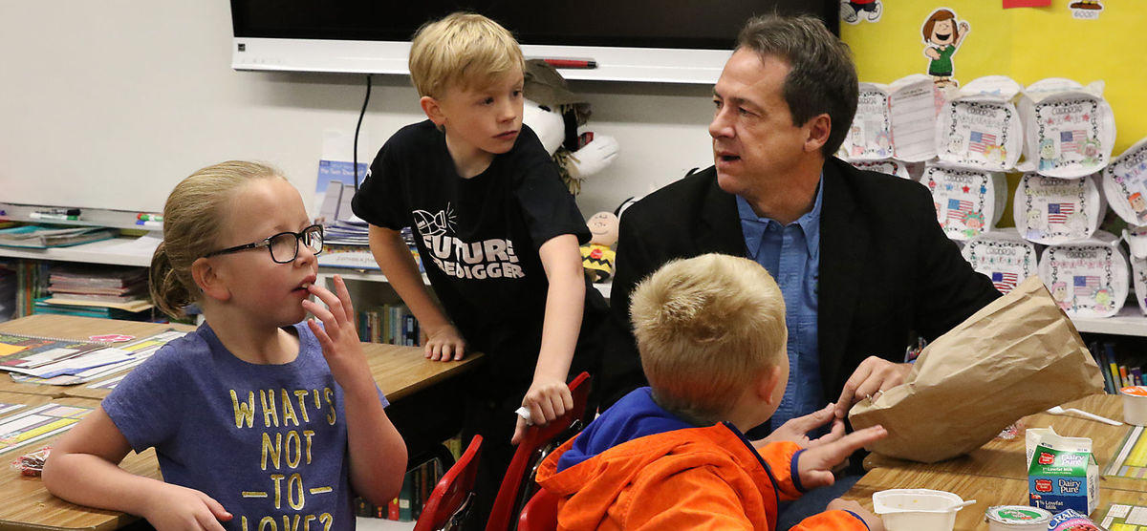

References:

American Academy of Pediatrics (AAP): Planning Considerations: Guidance for School Reopening

[https://services.aap.org/en/pages/2019-novel-coronavirus-covid-19-infections/clinical-guidance/covid-19- planning-considerations-return-to-in-person-education-in-schools/](https://services.aap.org/en/pages/2019-novel-coronavirus-covid-19-infections/clinical-guidance/covid-19-%20planning-considerations-return-to-in-person-education-in-schools/)

Butte Silver Bow Health Department: <https://www.co.silverbow.mt.us/135/Health>

Centers for Disease Control and Prevention, (2017) Quarantine and Isolation

CDC Coronavirus Disease – Community, Work & School Disinfecting Your Facility July 28th, 2020

<https://www.lethsd.ab.ca/download/280865> - [2020-2021 Guidelines for Health and Safety RE-ENTRY PLAN](https://www.lethsd.ab.ca/download/280865)

Centers for Disease Control (CDC): Guidance for Reopening Schools <https://www.cdc.gov/coronavirus/2019->ncov/community/schools-childcare/index.html ⋅ Governor Bullock, Lt. Governor Cooney: Plan for Reopening Safe and

Department of Health and Human Services: <https://dphhs.mt.gov/publichealth/cdepi/diseases/coronavirusmt>

Governor Bullock, Lt. Governor Cooney: Plan for Reopening Safe and Healthy Schools for Montana https://covid19.mt.gov/Portals/223/Documents/Education%20Final.pdf

Montana Office of Public Instruction: Reopening Montana’s Schools Guidance http://opi.mt.gov/Portals/182/COVID-19/Reopening%20MT%20Schools%20Guidance-Final.pdf?ver=2020- 07-02-114033-89

NASN (National Association of School Nurses) Considerations for School Nurses Regarding Care of Students

and Staff that Become Ill at School or Arrive Sick 3/18/2020.

World Health Organization (WHO): Q&A: Schools and COVID-19 https://www.who.int/news-room/q-a-detail/q-a-schools-and-covid-19

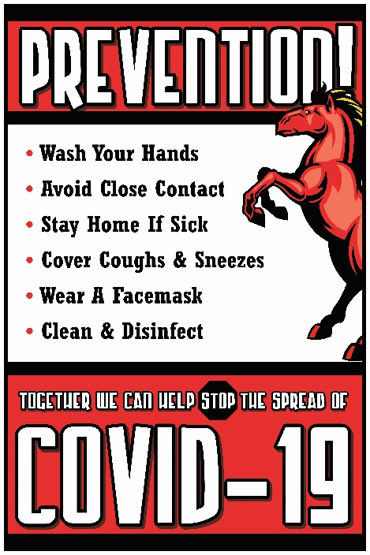

Appendix A

COVID-19 Data for Butte-Silver Bow

(as of 8/10/2020)

This report is completed using data that is available at the time of analysis and there may be a delay between current case count and this report, due to rapidly changing updates. This data is based on information available as of 8/10/20. Current case count at the time of this report in Butte-Silver Bow is:

Case Count = 100

Case Data

The first COVID case in Butte-Silver Bow was reported during the week of 3/13/20 – 3/20/2020, with 10 more cases following between 3/21/20 – 4/3/20. Butte-Silver Bow did not add another case until the week of 6/20/20 – 6/26/20. The below table represents cases in Butte-Silver Bow according to the date the case was reported.

Age Distribution

The age range for cases in Butte-Silver Bow is age 3 – age 83 and the average age is 43.5. The below table represents the age range of cases in Butte-Silver Bow.

Transmission Characteristics

Transmission changes over time with timely investigations, thorough contact tracing, and measures to reduce community-acquired transmission. Categories for reporting transmission:

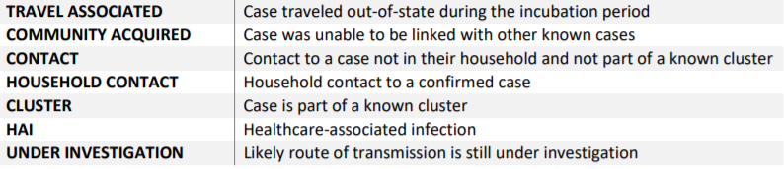

The below table represents known routes of transmission for COVID-19 in Butte-Silver Bow.

*(Data provided by the Butte Silver Bow Health Departmetn)*

*Appendix B*

**Frequently Asked Questions for**

**Butte School District Staff**

**Q: What steps can I take to prepare myself against the transmission of COVID-19?**

1. *The power to protect our educational community from coronavirus lies with each and every one of us. Please practice the following hand-washing and respiratory hygiene habits to protect yourself and those around you:*

* *Wear a face covering*
* *Cover your mouth and nose with a tissue or your sleeve (not your hands) when coughing or sneezing.*
* *Clean your hands by washing them with soap and water for at least 20 seconds or using an alcohol-based hand sanitizer that contains 60%–95% alcohol immediately after coughing, sneezing, or blowing your nose. Soap and water should be used if hands are visibly dirty.*
* *Stay home if you're sick.*

***Please see the CDC's guide for***[***preventing the spread of COVID-19***](https://www.cdc.gov/coronavirus/2019-ncov/community/index.html?CDC_AA_refVal=https%3A%2F%2Fwww.cdc.gov%2Fcoronavirus%2F2019-ncov%2Fpreparing-individuals-communities.html)***in communities.***

**Q: Where can I get more information on medical leave under the Families First**

**Coronavirus Response Act?**

1. *Information on employee rights under the Families First Coronavirus Response Act can found by accessing the Butte School District website at* [*https://www.bsd1.org/*](https://www.bsd1.org/) *or contacting the Butte School District Human Resource Department at 533-2506 or haydenal@bsd1.org*

Q: Will the District know if someone has COVID-19?

1. *If a Butte School District employee is associated with a confirmed case of COVID-19, they would not need to worry about being a close contact unless they are contacted by the Health Department. Employees must know that once a person has been identified as a confirmed COVID-19 case, they are deserving of privacy and confidentiality. The privacy rule of the Federal Health Insurance Portability and Accountability Act (HIPAA) establishes national standards to protect individual’s medical records and other personal health information. HIPAA still applies in a pandemic.*

**Q: I have tested positive or have been informed I am a close contact. What should I expect?**

1. *The Butte Silver Bow Health Department will get in touch with you and will start the protocol for quarantine/isolation and will start contact tracing. Staff confirmed as a close contact by the Health Department will be placed in quarantine for 14 days. Please report absences in Aesop and contact your administrator and Human Resource Office to get information regarding your absence. Please see the information on COVID-19 leave that is posted on the district’s website* [*https://www.bsd1.org/*](https://www.bsd1.org/) *.*

*Staff who have tested positive will be placed in isolation for at least 10 days since symptoms first appeared and at least 24 hours with no fever without fever reducing medication. In severe cases the isolation period could be up to 20 days. Please see the information on COVID-19 leave that is posted on the district’s website* [*https://www.bsd1.org/*](https://www.bsd1.org/) *. Staff returning to work should provide a doctor’s release to the Human Resource Office.*

*The Health Department will communicate with Butte School District to ensure cases are tracked and appropriate district individuals can be notified in a confidential manner.*

*If you are notified by an agency or an individual not associated with the Butte-Silver Bow Health that you are a close contact, please contact the Butte-Silver Bow Health Department immediately. The Health Department will confirm if you are a close contact.*

**Q: What is a close contact?**

1. *A close contact is someone who was within 6 feet of an infected person for at least 15 minutes, starting from two days before the onset of the illness. Close contacts of asymptomatic patients are identified as those who were close to the asymptomatic individual two days prior to a specimen collection that is positive, and until the time the patient is isolated.*

*A close contact can also be defined as:*

* *Someone who took care of a person at home who is sick with COVID-19*
* *Someone who had direct physical contact with the infected person (touching, hugging, kissing)*
* *Someone who shared eating or drinking utensils with the infected person*
* *Someone who is the recipient of respiratory droplets from the infected person, via sneezing or coughing*

*Once the Health Department is notified by the state that a person is confirmed as positive, the health department will work with that individual on isolation measures. The health department also works with that person to identify his or her close contacts. Then the health department works with those close contacts to quarantine and get tested. The identity of the person who tested positive is confidential and will not be released to others, not even those who are close contacts. When the Health Department reaches out to the close contact they just inform the person that they have been identified as a close contact by a patient but they do not release the name. The individual who is confirmed positive may share with others if they choose.*

*If someone is associated with a confirmed case of COVID-19, that person would not need to worry about being a close contact, unless they are contacted by the Health Department and informed that they are a close contact. Secondary contacts and more remote contacts would not be contacted by the department and therefore do not need to take any action nor quarantine. They would continue to proceed as normal.*

*If you are notified by an agency or an individual not associated with the Butte-Silver Bow Health that you are a close contact, please contact the Butte-Silver Bow Health Department immediately. The Health Department will confirm if you are a close contact.*

**Q. What if a student in my in-person class tests positive for COVID-19?**

1. *Butte School District instructs anyone with symptoms to contact their health care provider or Southwest Montana Community Health Center. If someone tests positive to COVID-19, the Butte Silver Bow Health Department will contact the patient with additional information.*

*The Health Department will contact anyone that is considered to have been in close contact with the individual who tests positive. Anyone who has had close contact with the person will be contacted by the Butte-Silver Bow Health Department. The employee should not take any further action. Please remember that this information is considered confidential and should not be shared with the class or anyone else.*

*In the event that there is a positive test in your classroom your classroom will be closed off until the sanitization and disinfection is completed. If an empty classroom is not available that class or cohort may need to move to a remote learning environment until the disinfection routine is completed. All stakeholders will be notified as soon as possible in the event that we need to move to a remote learning environment.*

*In the event that one or more individuals become sick, and sufficient personnel is not available to continue with in person learning the class or cohort may need to move to a remote learning environment. All stakeholders will be notified as soon as possible in the event that we need to move to a remote learning environment.*

*The Health Department will contact anyone that is considered to have been in close contact with the individual who tests positive. A close contact is someone who was within 6 feet of an infected person for at least 15 minutes, starting from two days before the onset of the illness. Close contacts of asymptomatic patients are identified as those who were close to the asymptomatic individual two days prior to a specimen collection that is positive, and until the time the patient is isolated.*

**Q. Should I come to work if I feel ill?**

1. *You must stay at home and not come to work if you are ill. Please contact the nurse assigned to your building, they have a questionnaire that they will go through with you. This directive on face coverings complements other important community and self-protection measures which are to be consistently practiced by all faculty, staff, students, and visitors.*

*These Stop the Spread of COVID-19 measures include:*

* *Wear a face covering*
* *Self-monitoring for symptoms and staying home when ill and reporting to your supervisor any exposure to COVID-19 positive individuals*
* *Washing hands often and thoroughly*
* *Refraining from touching the face, eyes, nose, and mouth*
* *Practicing physical distancing*
* *Regularly cleaning and disinfecting surfaces*

**Q. Will face coverings be required while teaching? If so, will the District provide those?**

1. *Teachers and support staff will be provided a face covering and a face shield at no cost. They are available at your individual building. A face covering that covers the nose and mouth and chin are the preferred covering. A face shield may be used instead when social distancing of a minimum of 6 feet is strictly adhered when a staff member is providing instruction. However, once the teacher or support staff leaves the instructional environment, a face covering must be used. The face shield is only to be used at all times if there is a medical need and a special accommodation has been approved by Human Resources. Staff members who wish to use a face shield must also have a medical need and work with Human Resources.*

*Face coverings will be required in all outdoor spaces where physical distancing is not possible or difficult to reliably maintain.*

*Each District building will have on stock an ample supply of disposable masks that will be available to all district employees.*

Q. Do I need to wear a face covering in my office?

1. *For employees that are not public facing, protected by a partition, or can maintain six feet of physical distance from their co-workers, they do not have to wear a mask. However, if you walk into a high-traffic area, such as a public bathroom, another office, or attend a meeting, a mask must be worn. If you have a private office, you do not have to wear a face covering in your office but must put it on when you leave the office or when someone enters your office.*

**Q. I am a medically high-risk or immune-compromised employee, what accommodations can be made for in-person class participation?**

1. *Faculty and staff whose unique and individual circumstances require an exception to the face covering directive, as indicated by a medical or similar subject matter professional, may request one. Faculty and staff should contact Therese McClafferty* [*mcclaffertyta@bsd1.org*](mailto:mcclaffertyta@bsd1.org)

Q. Does the District have the right to ask about symptoms, require me to stay at home and request medical documentation to return to work?

*A. Employers are allowed to ask about coronavirus-related symptoms* [*of employees*](https://www.shrm.org/resourcesandtools/legal-and-compliance/employment-law/pages/eeoc-coronavirus-temperature.aspx)*under guidance from the Equal Employment Opportunity Commission (EEOC). During a pandemic, the District may ask such employees if they are experiencing symptoms of the pandemic virus. For COVID-19, these include symptoms such as fever, chills, cough, shortness of breath, or sore throat. Employers must maintain all information about employee illness as a confidential medical record in compliance with the ADA.*

*The CDC states that employees who become ill with symptoms of COVID-19 should leave the workplace. The ADA does not interfere with employers following this advice. Requests for medical documentation to return to work are permitted under the ADA.*

**Q. How can I learn more about the safety and cleaning measures in place for in-person learning environments?**

1. *Regular cleaning practices are being enhanced by physical facilities, including frequent cleaning and sanitization of high-touch areas such as door handles, railings and increasing cleaning staff.*

* *A modified daily schedule has been implemented in order to properly clean and disinfect schools.*
* *Cleaner, hand sanitizer, and disposable wiping cloths are available for offices, classrooms, and common spaces.*
* *Traffic flow is being adjusted to reduce close contact.*
* *Plexiglass barriers will be available at each school contact your building administrator regarding these barriers.*
* *Physical distancing markers are placed around all buildings.*
* *Interior doors will be propped open during operational hours to reduce touchable areas.*
* *All buses will be equipped with disinfecting wipes or spray.*

***This is a shared responsibility. Please do your part to keep your spaces clean and to avoid sharing spaces and/or equipment.***

CONTACT INFORMATION:

BSD #1 Human Resources: 533-2506

School Nurses Work Numbers

* Dot Warner: 533-2257
* Barb Brown: West: 533-2700, Kennedy: 533-2450
* Katie Yates: Hillcrest: 533-2850, Emerson: 533-2800, Margaret Leary: 533-2550
* Jennifer McEwen: East 533-2605, Whittier: 533-2890

Southwest Community Health Center 406-723-4075

Butte Silver Bow Coronavirus Hotline 406-497-5008

Butte Silver Bow Health Department 406-497-5020

*Appendix C*

Families/Students

Frequently Asked Questions:

The safety of our students, staff and the entire Butte community is our priority as we begin our phased approach to reopening schools. We have in collaboration with the Butte Silver Bow Health Department created a fact sheet that contains protocols and procedures consistent with the health guidelines:

Section 1: COVID-19

**Q: What steps can I take to prepare myself against the transmission of COVID-19?**

1. *The power to protect our educational community from coronavirus lies with each and every one of us. Please practice the following hand-washing and respiratory hygiene habits to protect yourself and those around you:*

* *Wear a face covering*
* *Cover your mouth and nose with a tissue or your sleeve (not your hands) when coughing or sneezing.*
* *Clean your hands by washing them with soap and water for at least 20 seconds or using an alcohol-based hand sanitizer that contains 60%–95% alcohol immediately after coughing, sneezing, or blowing your nose. Soap and water should be used if hands are visibly dirty. Always wash hands before eating and after using the restroom.*
* *Stay home if you're sick.*

**Q. How do I screen my child prior to coming to school every day?**

1. *Check temperature: Is their temperature 100 degrees F or >?*

*If yes- stay home from school*

1. *Has their temperature been 100 degrees F or > in past 3 days (with or without the use of fever reducing medications including but not limited to (Tylenol, Acetaminophen, ibuprofen, Aleve, Advil, and generic equivalents)?*

*If yes stay home from school setting*

1. *Do you have any of the following symptoms?*

* *Fever (per above 100 or >*
* *Sore throat*
* *Cough- new or changes in a cough*
* *Shortness of breath/difficulty breathing*
* *Sneezing*
* *New Loss of taste*
* *New Loss of sense of smell*
* *Chills*
* *New rash on hands or feet*
* *Nausea*
* *Vomiting*
* *Diarrhea*

*If yes to any - stay home from school setting- consult your health care provider or the local health department for further advice – if work absence or return suggested –provide written documentation to school main office or school nurse*

1. *Is anyone in your immediate household able to answer Yes to any of the above questions?*

*If yes- refrain from school entry until consulting your health care provider, local health department or school nurses*

1. *Have you or a household member been asked to quarantine for COVID 19 testing, diagnosis, or treatment?*

*If yes- refrain from school entry until consulting your health care provider or local health department*

1. Do you have any of the following symptoms?

* *Headache/migraine*
* *Fatigue*
* *Body/Muscle aches*
* *Runny nose*
* *New dizziness*

*If yes to any of these symptoms – more information is required – refrain from school entry until consulting your health care provider or school nurse*

*If No to all of the above – entry to school setting is allowed- remember:*

* *Wear a face covering at all times when in the school setting and within 6 feet of other students or staff – avoid touching your eyes, nose, mouth and your face covering*
* *Maintain social distancing of a minimum of 6 feet (the length of most pool foam noodles)*
* *Wash your hands or sanitize throughout your time in the building, especially before eating, after using the restroom, as soon as possible after coughing, sneezing or touching surfaces that may have been touched by others*
* *Cover your cough and sneezes by coughing into elbow or collar, sneezing into tissue and turning away from others when doing so then trash the tissue and wash or sanitize your hands*
* *No handshakes, high fives, hugs, etc. as these all violate 6 feet social distancing*

Q: Will the District know if someone has COVID-19?

*.*

*The Health Department will communicate with Butte School District to ensure cases are tracked and appropriate district individuals can be notified in a confidential manner.*

*If you are notified by an agency or an individual not associated with the Butte-Silver Bow Health that you are a close contact, please contact the Butte-Silver Bow Health Department immediately. The Health Department will confirm that you are a close contact.*

**Q: What is a close contact?**

1. *A close contact is someone who was within 6 feet of an infected person for at least 15 minutes, starting from two days before the onset of the illness. Close contacts of asymptomatic patients are identified as those who were close to the asymptomatic individual two days prior to a specimen collection that is positive, and until the time the patient is isolated.*

*A close contact can also be defined as:*

* *Someone who took care of a person at home who is sick with COVID-19*
* *Someone who had direct physical contact with the infected person (touching, hugging, kissing)*
* *Someone who shared eating or drinking utensils with the infected person*
* *Someone who is the recipient of respiratory droplets from the infected person, via sneezing or coughing*

*Once the Health Department is notified by the state that a person is confirmed as positive, we work with that individual on isolation measures. They also work with that person to identify his or her close contacts. They then work with those close contacts to quarantine and get tested. The identity of the person who tested positive is confidential and will not be released to others, not even those who are close contacts. When the Health Department reaches out to the close contact they just inform the person that they have been identified as a close contact by a patient but they do not release the name. The individual who is confirmed positive may share with others if they choose.*

*If someone is associated with a confirmed case of COVID-19, that person would not need to worry about being a close contact, unless they are contacted by the Health Department and informed that they are a close contact. Secondary contacts and more remote contacts would not be contacted by the department and therefore do not need to take any action nor quarantine. They would continue to proceed as normal.*

*If you are notified by an agency or an individual not associated with the Butte-Silver Bow Health that you are a close contact, please contact the Butte-Silver Bow Health Department immediately. The Health Department will confirm that you are a close contact.*

**Q****: What if someone in my in-person class tests positive for COVID-19?**

1. *Butte School District instructs anyone with symptoms to contact their health care provider or Southwest Montana Community Health Center. If someone tests positive to COVID-19, the Butte Silver Bow Health Department will contact the patient with additional information.*

*In the event that one or more individuals become sick, and sufficient personnel is not available to continue with in person learning the class or cohort may need to move to a remote learning environment. All stakeholders will be notified as soon as possible in the event that we need to move to a remote learning environment.*

*The Health Department will contact anyone that is considered to have been in close contact with the individual who tests positive. A close contact is someone who was within 6 feet of an infected person for at least 15 minutes, starting from two days before the onset of the illness. Close contacts of asymptomatic patients are identified as those who were close to the asymptomatic individual two days prior to a specimen collection that is positive, and until the time the patient is isolated.*

*Once the Health Department is notified by the state that a student is confirmed as positive, they work with that student on isolation measures.*

*If a student is associated with a confirmed case of COVID-19, that student would not need to worry about being a close contact, unless they are contacted by the Health Department and informed that they are a close contact. Secondary contacts and more remote contacts would not be contacted by the department.*

*If you are notified by an agency or an individual not associated with the Butte-Silver Bow Health that you are a close contact, please contact the Butte-Silver Bow Health Department immediately. The Health Department will confirm that you are a close contact.*

**Q: Will face coverings be required for all students?**

1. *Face coverings are required for grades K-12. Students will be provided one cloth mask at no cost and disposable masks will be available in the event that a student forgets their mask. Parents are welcome to purchase their own masks for their students.*

*CDC guidelines for the use and care of face masks should be followed and are accessible here:*[*www.cdc.gov*](http://www.cdc.gov/)

*The following individuals****should not use****cloth face masks:*

* *Children 2 years of age and under; and*
* *Anyone who has trouble breathing, or is unconscious, incapacitated, or otherwise unable to remove the cover without assistance.*

*A multi-ply tightly woven cotton cloth or multi-ply disposable face covering is recommended. When worn, the covering must extend from the bridge of the nose to below the chin. Reusable cloth face coverings are acceptable, as are disposable paper masks. Cloth face coverings should:*

* *Fit snugly but comfortably against the side of the face*
* *Be secured with ties or ear loops*
* *Include multiple layers of fabric*
* *Allow for breathing without restriction*
* *Be able to be laundered and machine-dried without damage or change to shape*
* *The face-covering must not have an exhalation valve*
* *Daily laundering of cloth face coverings is STRONGLY recommended*

**Q: What if I don't wear a face covering in class?**

1. *Butte School District is asking all students to be responsible and wear their masks for the health and safety of others. Anyone who fails to abide by this directive may be asked or directed to leave the school.*

Q: What is a reasonable accommodation to a face mask?

1. *If an accommodation is approved, a student may wear a full-face shield instead of a face mask. The Butte School District has some face shields available for students upon request.*

Q. How can I learn more about the safety and cleaning measures in place for in-person learning environments?

1. *Regular cleaning practices are being enhanced by physical facilities, including frequent cleaning and sanitization of high-touch areas such as door handles, railings and increasing cleaning staff.*

* *A modified daily schedule has been implemented in order to properly clean and disinfect schools.*
* *Cleaner, hand sanitizer, and disposable wiping cloths are available for offices, classrooms, and common spaces.*
* *Traffic flow is being adjusted to reduce close contact.*
* *Plexiglass barriers added throughout each facility.*
* *Physical distancing markers are placed around all buildings.*
* *Interior doors will be propped open during operational hours to reduce touchable areas.*
* *All buses will be equipped with disinfecting wipes or spray.*

Section 2: Reopening Plans

Q. Where can I find a copy of the Butte School District Reopening Plan?

*A. The reopening plan is posted on the District’s website at*[*https://www.bsd1.org/*](https://www.bsd1.org/)

Q. In what phase will the students begin school this Fall?

*A. Currently, the Butte School District is scheduled to reopen under Phase II of the Reopening plan. This phase includes a modified daily schedule that includes a remote learning component along with a cohort model. The following is the planned modified daily schedule:*

*Grades: K-3: Monday-Thursday 8:20-1:00 Friday 8:20-11:30*

*Grades: 4-6: Monday-Thursday: 8:20-2:00 Friday 8:20-11:05*

*Grades: 7-12: Monday-Thursday: 8:20-2:00 Friday 8:20-11:05*

*Please note that this situation is constantly changing and the Butte School District may need to move to a more restrictive Phase of the plan based on the recommendations from state and local officials. We will continue to monitor the situation and will update parents of any changes to the schedule.*

Q. When is the first day of school for students?

*A. Currently, the district is scheduled to start school on August 31st. We will continue to keep you updated if there are any changes to the start date.*

Q. How do I enroll my child in school?

*A. You can enroll your child for school using the online registration process that is available on the District’s website at* [*https://www.bsd1.org*](https://www.bsd1.org) *In order to complete the registration process you will need to bring your child’s immunization records and proof of residence to your school. It is recommended that you call the school prior to dropping off the documents in order that we maintain social distancing protocols.*

*Current immunization status is required for all students enrolled- both in school and remote learning*

Q. How do I enroll my child in remote learning?

A. *You will need to fill out the request form that is posted on the district’s website at* [*https://www.bsd1.org*](https://www.bsd1.org) *Please return the form to your child’s school or you can return the form to the Administration Building at 111 N Montana*

*Current immunization status is required for all students enrolled- both in school and remote learning*

Q. Will my child have access to technology if we request remote learning?

*A. Yes, you can arrange to check out technology equipment with your building administrator. Paper and pencil packets may be available depending on the individual needs of the student. Please contact your building administrator to get more specifics relating to remote learning.*

Q. Will I be required to report my child’s absence is he/she is receiving instruction via remote learning?

*A, Yes, students receiving instruction via remote learning are required to check in with their teacher on a daily basis. We are also requesting the parents to report absences on any day that their child will not be attending school via remote learning.*

Q. Will the District’s breakfast and lunch program be available to students?

*A. Yes, we are committed to continue providing quality meals across all phases of our reopening plan. In Phase I and II students will eat lunch and breakfast in their classrooms in order to provide the best possible service while reducing the risks of virus transmission.*

Q. Will transportation be available for in-person instruction?

*A. Yes, transportation will be available for the 2020-2021 school year. It is important that you register your child with the Transportation Department as soon as possible. Please know in order to meet the requirements of social distancing bus routes are being redesigned. Therefore, it is important to register as soon as possible.*

Q. Will visitors be allowed in the school building?

*A. No, during the pandemic we are not allowing visitors into the building. If you need to speak with the principal or teacher please call and schedule a time to meet.*

CONTACT INFORMATION:

BSD #1 Human Resources: 533-2506

School Nurses Work Numbers

* Dot Warner: 533-2257
* Barb Brown: West: 533-2700, Kennedy: 533-2450
* Katie Yates: Hillcrest: 533-2850, Emerson: 533-2800, Margaret Leary: 533-2550
* Jennifer McEwen: East 533-2605, Whittier: 533-2890

Southwest Community Health Center 406-723-4075

Butte Silver Bow Coronavirus Hotline 406-497-5008

Butte Silver Bow Health Department 406-497-5020

